**Lesson 4**

* Comments on previous lesson.
* Today’s lesson activities.
* Do the activities on this document and upload it on POLIFORMAT – TAREAS.
* Deadline: During today’s class time

**Practice 4 - Medicine**

**PART 1**

**Page 151** New Language - Leader Meet the expert

**Activity 2b (write the number)**

1. **_3**
2. _1
3. _5
4. _4
5. _2

**Activity 3**

1. **_T, she expose an example about a boy of 18 years who have an accident**
2. **_F, bionic hearts it’s now used but only in labs because it’s expensive**
3. **_F, the brain is getting smaller, not bigger**
4. **_F, she said it’s only for patients**
5. **_T, they work with mechanical engineering**

**PART 2**

Discuss giving reasons for your opinions (4/5 lines maximum):

* Do you agree with Tina, that microchip technology should only be used with patients, not healthy people?

Yes, because the target is trying to make patients’ life normally like other people who do not have any problems. I think, healthy people who wants a microchip technology thinks to build a superhuman with many facilities, for example, have the phone in your arm. In my opinion this it is not necessary or fundamental in our lives, and maybe the process could be much expensive for some people, and it is more interesting make technology for everyone.

**Speaking Topic 4**

**PART 3**

**Discuss these ideas in the chat rooms.**

**Interaction (10 minutes maximum):**

1. **Discuss the implications of using microchips in humans:**

[**https://www.youtube.com/watch?v=0Ixr4SzoVJA&ab_channel=CBSThisMorning**](https://www.youtube.com/watch?v=0Ixr4SzoVJA&ab_channel=CBSThisMorning)

**2 members in the group agree with using microchips in humans and 2 disagree.**

Discuss these topics:

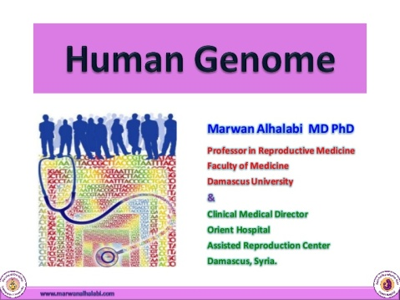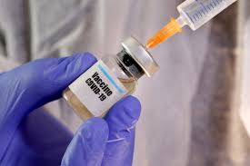**1. Why is research on these areas needed? Which is the most important area?**

In a pandemic, should vaccines be developed in public, government-funded research institutes or private pharmaceutical companies?

**2. Should we start introducing robot doctors?**

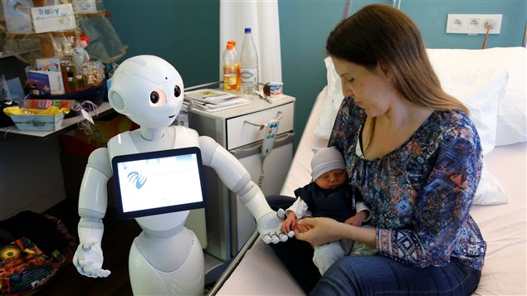

Would you like to have a robot doctor? Why / Why not?

**3. Should homeopathic medicine be legal?**

 

Should new drugs be tested on both animals and humans before being prescribed by doctors?

**4. Is mental health as important as physical health?**

 

Do you think going to the therapist should be free for everyone? Give reasons.